Scripting Languages

📌 Definition:
# Source: AI Source: Provided by: [Data Path: Persons Table -> ID Column: 1, Name_En Column: Motasem Essam] -> From: [Chatgpt (GPT‑5 Mini)] on [12/9/2025]
Scripting languages are high-level programming languages used to automate tasks, control applications, and quickly write programs, usually without a separate compilation step.

🧠 Simple idea:
# Source: AI Source: Provided by: [Data Path: Persons Table -> ID Column: 1, Name_En Column: Motasem Essam] -> From: [Chatgpt (GPT‑5 Mini)] on [12/9/2025]
Scripting = Write → Run directly (no heavy setup)

🔍 Key characteristics:
# Source: AI Source: Provided by: [Data Path: Persons Table -> ID Column: 1, Name_En Column: Motasem Essam] -> From: [Chatgpt (GPT‑5 Mini)] on [12/9/2025]
- ✅ Interpreted (run line-by-line)
- ✅ Easy and fast to write
- ✅ Used for automation and glue code
- ✅ Often embedded in other systems (web, apps, tools)

🧩 Examples:
# Source: AI Source: Provided by: [Data Path: Persons Table -> ID Column: 1, Name_En Column: Motasem Essam] -> From: [Chatgpt (GPT‑5 Mini)] on [12/9/2025]
- JavaScript 🌐
- Python 🐍
- PHP
- Bash / Shell scripting

⚙️ Interpreter

⚙️ What is an Interpreter?
# Source: AI Source: Provided by: [Data Path: Persons Table -> ID Column: 1, Name_En Column: Motasem Essam] -> From: [Chatgpt (GPT‑5 Mini)] on [12/9/2025]
An interpreter is a program that executes high-level code (like Python or JavaScript) line by line, without converting the whole program into machine code first.

📌 Simple definition:
# Source: AI Source: Provided by: [Data Path: Persons Table -> ID Column: 1, Name_En Column: Motasem Essam] -> From: [Chatgpt (GPT‑5 Mini)] on [12/9/2025]
Interpreter = Reads and runs code line-by-line

🧠 Simple idea:
# Source: AI Source: Provided by: [Data Path: Persons Table -> ID Column: 1, Name_En Column: Motasem Essam] -> From: [Chatgpt (GPT‑5 Mini)] on [12/9/2025]
You write code → interpreter reads it → executes immediately → moves to next line

🔍 How it works:
# Source: AI Source: Provided by: [Data Path: Persons Table -> ID Column: 1, Name_En Column: Motasem Essam] -> From: [Chatgpt (GPT‑5 Mini)] on [12/9/2025]
- Read the first line of code
- Translate it into machine instructions
- Execute it immediately
- Repeat for the next line

🧩 Example:
# Source: AI Source: Provided by: [Data Path: Persons Table -> ID Column: 1, Name_En Column: Motasem Essam] -> From: [Chatgpt (GPT‑5 Mini)] on [12/9/2025]
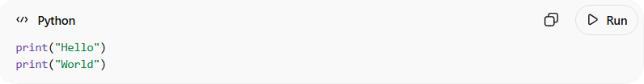
print("Hello")
print("World")
👉 The interpreter:
- Runs print("Hello")
- Then runs print("World")

🧩 Languages that use interpreters:
# Source: AI Source: Provided by: [Data Path: Persons Table -> ID Column: 1, Name_En Column: Motasem Essam] -> From: [Chatgpt (GPT‑5 Mini)] on [12/9/2025]
- Python 🐍
- JavaScript 🌐
- PHP
- Ruby

🆚 Interpreter vs Compiler
# Source: AI Source: Provided by: [Data Path: Persons Table -> ID Column: 1, Name_En Column: Motasem Essam] -> From: [Chatgpt (GPT‑5 Mini)] on [12/9/2025]
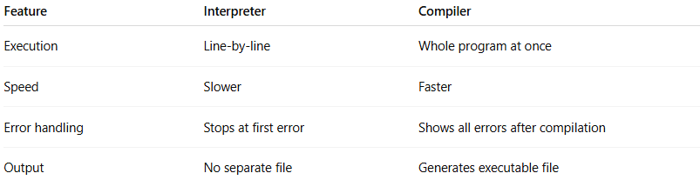
Feature | Interpreter | Compiler
Execution | Line-by-line | Whole program at once
Speed | Slower | Faster
Error handling | Stops at first error | Shows all errors after compilation
Output | No separate file | Generates executable file

🎯 Key points:
# Source: AI Source: Provided by: [Data Path: Persons Table -> ID Column: 1, Name_En Column: Motasem Essam] -> From: [Chatgpt (GPT‑5 Mini)] on [12/9/2025]
- ❌ No full compilation step
- ⚡ Good for testing and debugging
- 🧪 Widely used in scripting languages

✅ Summary:
# Source: AI Source: Provided by: [Data Path: Persons Table -> ID Column: 1, Name_En Column: Motasem Essam] -> From: [Chatgpt (GPT‑5 Mini)] on [12/9/2025]
An interpreter directly executes code line by line, making development easier and faster for testing, but usually slower than compiled programs.

⚙️ How it works:
# Source: AI Source: Provided by: [Data Path: Persons Table -> ID Column: 1, Name_En Column: Motasem Essam] -> From: [Chatgpt (GPT‑5 Mini)] on [12/9/2025]
- You write a script
- The interpreter runs it directly
- The result is executed immediately

🧩 Example:
# Source: AI Source: Provided by: [Data Path: Persons Table -> ID Column: 1, Name_En Column: Motasem Essam] -> From: [Chatgpt (GPT‑5 Mini)] on [12/9/2025]
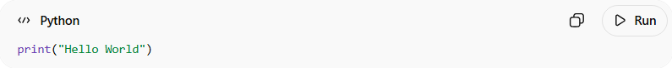
print("Hello World")
👉 No compilation step needed — just run it.

🎯 Where they are used:
# Source: AI Source: Provided by: [Data Path: Persons Table -> ID Column: 1, Name_En Column: Motasem Essam] -> From: [Chatgpt (GPT‑5 Mini)] on [12/9/2025]
- 🌐 Web development (JavaScript)
- 🤖 Automation (Python, Bash)
- 🔧 System tasks and scripting
- 🧪 Testing and test automation

🆚 Scripting vs Other Languages
# Source: AI Source: Provided by: [Data Path: Persons Table -> ID Column: 1, Name_En Column: Motasem Essam] -> From: [Chatgpt (GPT‑5 Mini)] on [12/9/2025]
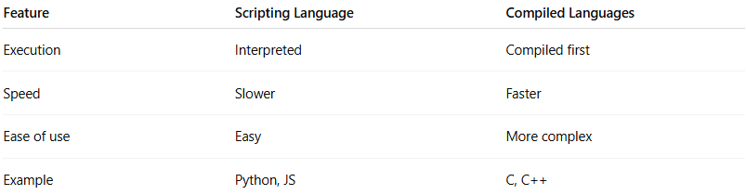
Feature | Scripting Language | Compiled Languages
Execution | Interpreted | Compiled first
Speed | Slower | Faster
Ease of use | Easy | More complex
Example | Python, JS | C, C++

✅ Summary:
# Source: AI Source: Provided by: [Data Path: Persons Table -> ID Column: 1, Name_En Column: Motasem Essam] -> From: [Chatgpt (GPT‑5 Mini)] on [12/9/2025]
Scripting languages are easy-to-use high-level languages designed for quick development, automation, and controlling applications without complex compilation.

